1.Select Router 2911 and a Pc from End Devices



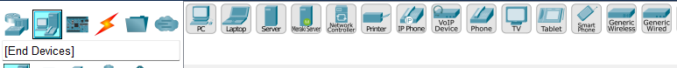

2.Then go to connection and select console connection

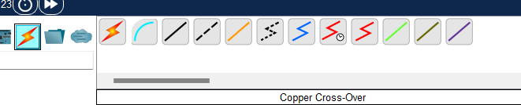

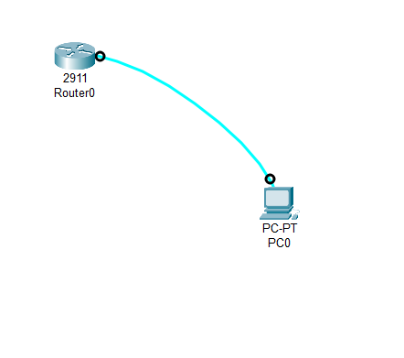

3. Open Terminal and Execute the Following commands

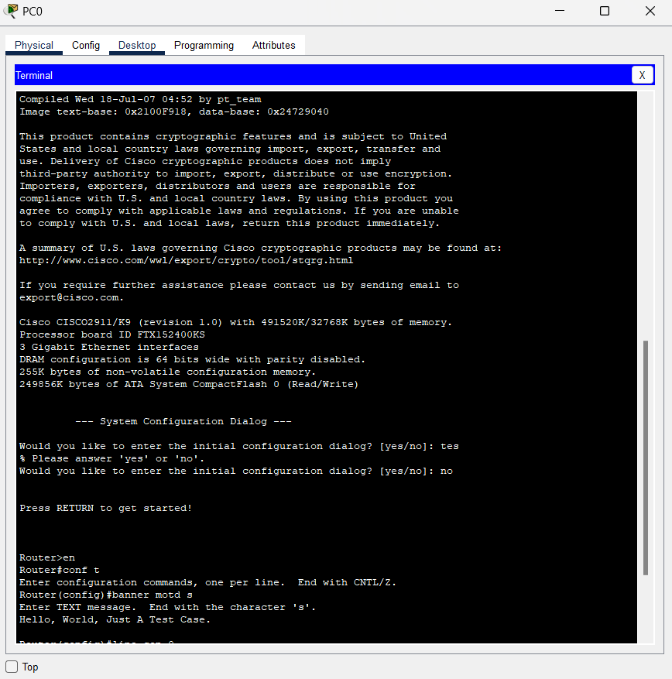

On every next login it will ask for password

